Multithreaded Programming
Thread
A thread is similar to a program that has a single flow of control. It has a beginning, a body, and an
end, and executes commands sequentially. In fact main program in our programs can be called as Thread.
A unique property of java is multithreading. That is java enables us to use multiple flows of control in developing programs. Each flow of control may be separate Tiny Program or module known as a Thread. A program that contains multiple flows of control is known as Multithreaded Program.
Threads in java are subprograms of a main application program, they can share the same memory
space, and saves the CPU time, they are known as Lightweight Processes or Lightweight Threads. All the threads are running on a single processor, the flow of execution is shared between the threads.

Note: Threads running in parallel doesn’t really mean that they actually run at the same time. Since all the threads are running on a single processor ,the flow of execution is shared between the threads. The java interpreter handles the switching of control between the threads in such a way that it appears they are running concurrently.

Difference between single threaded and multithreaded program is shown in below figures.
A single threaded program contains a beginning ,single thread body and an end as shown below.
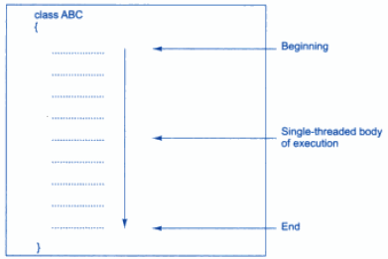
fig(a): Single threaded Program

On the other hand consider a program which contains multiple threads as shown in the figure below.
It contains four threads, one main thread and three others. The main thread is the main() module ,which is designed to create and start the other three threads (namely A,B,C).
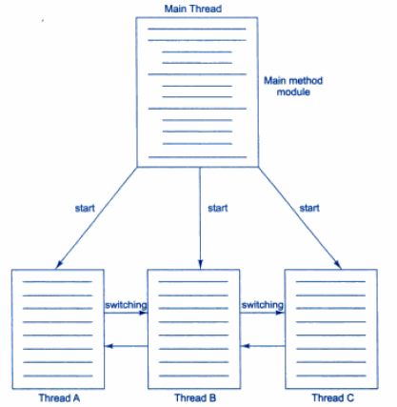
fig(a): Multithreaded Program

Advantages of using multiple threads:
- It enables the programmers to do multiple things at one time.
- Long program can be divided in to threads (sub programs) and execute them in parallel.
- An application which requires two or more things to be done at the same time ,then it’s a good choice to use a thread.

Difference between Multi Threading and Multi Tasking :

MULTI THREADING | MULTI TASKING
It is a programming concept in which a program or process is divided into two or more  subprograms or threads that are executed at the same time in parallel. | It is an operating system concept in which multiple tasks are performed simultaneously.
It supports execution of multiple parts of a single program simultaneously. | It supports execution of multiple programs simultaneously.
The processor has to switch between different parts or threads of a program. | The processor has to switch between different programs or processes.
It is highly efficient. | It is less efficient in comparison to multithreading.
A thread is the smallest unit in multithreading. | A Program or process is the smallest unit in a multitasking environment.
It helps in developing efficient programs. | It helps in developing efficient operating systems.
It is cost-effective in case of context switching. | It is expensive in case of context switching.

Creating Thread
Thread can be created in two ways:

- By extending Thread class:

Define a class that extends Thread class and override its run ( ) method with the code required by the thread. Threads are implemented in the form of objects that contain a method called run(). The run() method is the heart and soul of any thread. A typical run() would appear as follows.

public void run()
{
…………
…………
…………(Statements for implementing thread)
…………
}

The run ( ) method should be invoked by an object of the concerned thread class. This can be achieved by creating the thread and initiating it with the help of another thread method called start().

- By implementing Runnable interface:

Define a class that implements Runnable interface. The Runnable interface has only one
method, run ( ), that is to be defined in the method with the code to be executed by the thread.

The approach to be used depends on what the class we are creating requires. That means if our class requires to extend another class ,then we have no choice but to implement the Runnable interface, since java classes do not have two super classes .

Extending Thread Class
We can make our class as thread by extending the class java.lang.Thread. This gives us access to all
the thread methods directly. It includes the following steps:
- Declare the class as extending the Thread class

class MyThread extends Thread
{
……
……
……
}
- Implement the run ( ) method that is responsible for executing the sequence of code that the thread will execute.

public void run()
{
…………
…………
…………(Statements for implementing thread)
…………
}

- Create a thread object and call the start ( ) method to initiate the thread execution.

MyThread t = new MyThread ();

t.start(); // invokes run() method

Here first statement just creates the object. Now the MyThread is in a newborn state. The second line
calls the start() method causing the thread to move into the runnable state. Then the java runtime will schedule the thread to run by invoking its run() method. Now thread is said to be in running state.

The following program illustrates the concept of extending the thread class.
import java.lang.*;
class One extends Thread
{
public void run()
{
for(int i=1;i<=5;i++)
{
System.out.println("From Thread One: i =" + i);
}
System.out.println("Exiting from the Thread One");
}
}
class Two extends Thread
{
public void run()
{
for(int j=1;j<=5;j++)
{
System.out.println("From Thread Two: j =" + j);
}
System.out.println("Exiting from the Thread Two ");
}
}
class CheckThread
{
public static void main(String ar[])
{
One a=new One();
Two b=new Two();
a.start(); // invoke run() method of One thread
b.start(); // invoke run() method of Two thread
System.out.println("Exiting from the main");
}
}
output :
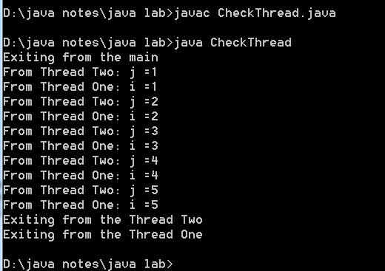

Stopping and Blocking a Thread
Stopping a Thread
Whenever we want to stop a thread from running further, we may do so by calling its stop() method,
like: Thred.stop( );
This statement causes the thread to move to the dead state. A thread will also move to the dead state
automatically, When it reaches the end of its method. The stop () may be used when the premature (earlier than expected) of death of a thread is desired.
Blocking a Thread
A thread can also be temporarily suspended or blocked from entering into the runnable and subsequently running state by using either of the following thread methods:
sleep ( ) // blocked for a specified time
suspend ( ) // blocked until further orders
wait ( ) // blocked until certain condition occurs
These methods cause the thread to go into the blocked or not runnable state. The thread will return to
the runnable state when the specified time is elapsed in the case of sleep ( ), the resume ( ) method is invoked in the case of suspend ( ), and the notify ( ) method is called in the case of wait( ).

Lifecycle of a Thread
During the lifetime of a thread, it can enter many states. They include:
1. Newborn State
2. Runnable State
3. Running State
4. Blocked State
5. Dead State
A thread is always in one of these five states. It can move from one state to another via a variety of
ways as shown in below figure.

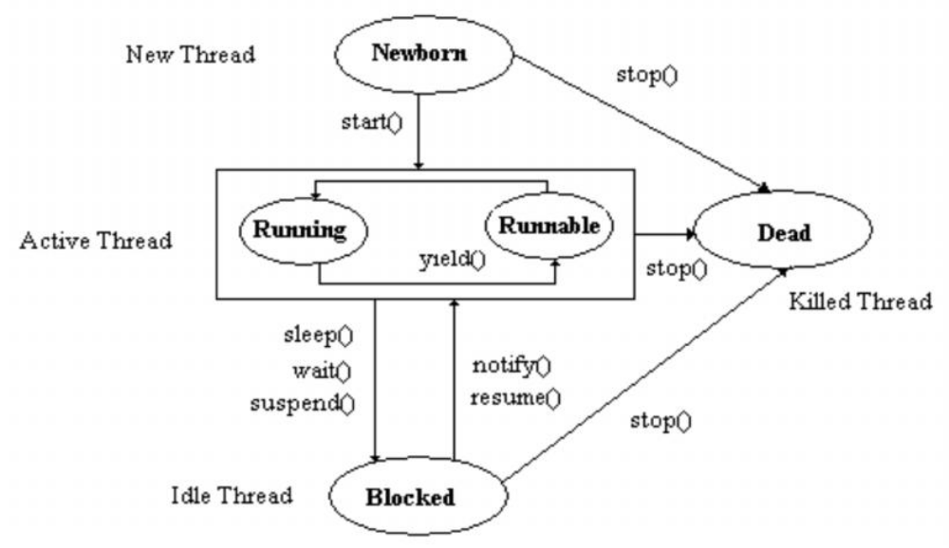

State Transition of a Thread

1. NewBorn State
When we create a Thread object, the Thread is born and is said to be in newborn state. The Thread is not yet scheduled for running.
At this state, we can do only one of the following things with it:
- Schedule it for running using start() method
- Kill it using stop() method
If scheduled (using start()) ,the newly born Thread moves to the runnable state.If we try to use any other method(other than start() and stop()) at this stage ,an exception will be thrown.

2. Runnable State
The Runnable state means that the thread is ready for execution and is waiting for the availability of
the processor. If all the threads have equal priority, then they are given time slots for execution in first-come, first-serve manner. The process of assigning time to Threads is known as time slicing. The thread that relinquishes (release) the control joins at the end of the queue and waits for its turn. we can manually make a thread to relinquish its control to another thread before its turn comes by using the yield().
3. Running State
Running means that the processor has given its time to the thread for its execution. The thread runs
until it relinquishes control on its own or it is preempted by a higher priority thread. A Thread may relinquish its control in one of the following situations.

- It has suspended by suspend() method. A suspended thread can be revived ( To restore to use) or resumed by using the resume() method.

- It has been made for sleep by using sleep(time) method. Where time is given in milliseconds (if given 1000 milliseconds its equal to one second ,so thread will be out of the queue during this time period). The thread re-enters the runnable state as soon as this time period is elapsed.

- It has been told to wait until some event occurs. This is done by using wait() method. The thread can be scheduled to run again using the notify() method.

4. Blocked State
A thread is said to be Blocked when it is prevented from entering into the runnable state and subsequently the running state. This happens when the thread is suspended, sleping, or waiting in order to satisfy certain requirements. A blocked thread is considered “not runnable” but not dead and therefore fully qualified to run again.
5. Dead State
Every thread has a lifecycle. A running thread ends its life when it has completed executing its run()
method. It is natural death. However, we can kill it by sending the stop message to it at any state thus causing a premature death to it. It is done by stop() method.

The following program illustrates the concept of the thread methods.
//sample java program showing the functionality of some of the methods of Thread class
import java.lang.*;
class One extends Thread
{
public void run()
{
for(int i=1;i<=5;i++)
{
if(i==1)
yield();
System.out.println("From Thread One: i =" + i);
}
System.out.println("Exiting from the Thread One");
}
}
class Two extends Thread
{
public void run()
{
for(int j=1;j<=5;j++)
{
System.out.println("From Thread Two: j =" + j);
if(j==3)
stop();
}
System.out.println("Exiting from the Thread Two");
}
}
class ThreadMethod
{
public static void main(String args[])
{
One a=new One();
Two b=new Two();
System.out.println("Thread One Started");
a.start();
System.out.println("Thread Two Started");
b.start();
System.out.println("Exiting from the main");
}
}
output:

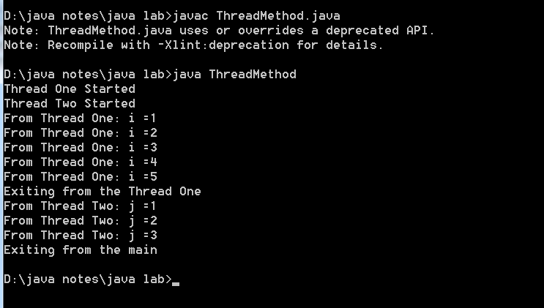

Thread Priority
In java, each thread is assigned a priority, which affects the order in which it is scheduled for running. The Threads of the same priority are given equal treatment by the java scheduler and, therefore, they share the processor on a First-Come, First-Serve basis.

Java permits us to set the priority of a thread using the setPriority() method as follows.

ThreadObject.setPriority(int Number);
The Number is an integer value ranging from 1 to 10. The Thread class defines several priority constants.
MIN_PRIOITY=1
NORM_PRIORITY=5
MAX_PRIORITY=10
The Number may assume one of these constants or any value between 1 and 10. The default setting is NORM _ PRIORITY.
Whenever multiple Threads are ready for execution, the Java system chooses the highest priority thread and executes it.

The following program illustrates the concept of thread priorities in java.
//sample java program which shows the functionality of thread priorities
import java.lang.*;
class One extends Thread
{
public void run()
{
for(int i=1;i<=5;i++)
{
System.out.println("From Thread One: i =" + i);
}
System.out.println("Exiting from the Thread One");
}
}
class Two extends Thread
{
public void run()
{
for(int j=1;j<=5;j++)
{
System.out.println("From Thread Two: j =" + j);
}
System.out.println("Exiting from the Thread Two ");
}
}
class Three extends Thread
{
public void run()
{
for(int k=1;k<=5;k++)
{
System.out.println("From Thread Three: k =" + k);
}
System.out.println("Exiting from the Thread Three ");
}
}
class ThreadPriority
{
public static void main(String ar[])
{
One a=new One();
Two b=new Two();
Three c=new Three();
c.setPriority(Thread.MAX_PRIORITY);
b.setPriority(Thread.NORM_PRIORITY);
a.setPriority(Thread.MIN_PRIORITY);

System.out.println("Start Thread One");
a.start();

System.out.println("Start Thread Two");
b.start();

System.out.println("Start Thread Three");
c.start();

System.out.println("Exit from main()");
}
}
output:
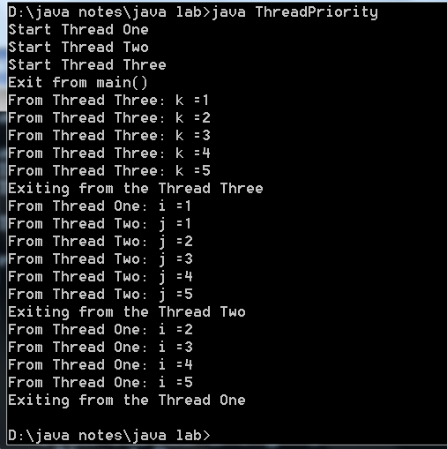

Thread Exceptions:
It is necessary to take care while calling method like sleep() .That means this method call should be enclosed in a try block followed by a catch block ,because sleep() throws InterruptedException.

Following is the declaration for java.lang.Thread.sleep() method
public static void sleep(long millis) throws InterruptedException
example :
try
{
ThreadObj.sleep(1000)
….
}
catch(InterruptedException e)
{
…..
}
Like this any other methods which throws exceptions should be handled using try and catch blocks.

Synchronizing Threads
Synchronization of threads ensures that if two or more threads need to access a shared resource then
that resource is used by only one thread at a time. You can synchronize your code using the synchronized keyword. You can invoke only one synchronized method for an object at any given time.
When a thread is within a synchronized method, all the other threads that try to call it on the same
instance have to wait. During the execution of a synchronized method, the object is locked so that no other synchronized method can be invoked.
When we declare a method synchronized, java creates a monitor and hands it over to the thread that
calls the method first time. As long as the thread holds the monitor, no other thread can enter the synchronized section of code. A monitor is like a key and the thread that holds the key can only open the lock. The monitor is automatically released when the method completes its execution.

The synchronized keyword can be used in two different ways
- synchronized keyword used in method declaration as shown in below example.
Syntax:
Thread A
{
synchronized method1()
{
// statements;
}
}
Thread B
{
synchronized method2()
{
// statements; }}
- synchronized keyword used inside a method definition as shown in below example.

public void method(parameter list){

synchronized(this){
…….
}
}

Implementing Runnable Interface
The Runnable interface declares the run ( ) method that is required for implementing threads in our
programs. To do this, we must perform the steps listed below:
1) Declare the class as implementing the Runnable interface.
2) Implement the run() method
3) call the thread‘s start() method to run the thread.

The following program illustrates the concept of implementing the Runnable Interface in java.
//creationg of thread using Runnable interface

import java.lang.*;
class One implements Runnable
{
public void run()
{
for(int i=1;i<=5;i++)
{
System.out.println("Thread One : i = " + i);
}
System.out.println("Exiting from the Thread One");
}
}
class Two implements Runnable
{
public void run()
{
for(int j=1;j<=5;j++)
{
System.out.println("Thread One : j = " + j);
}
System.out.println("Exiting from the Thread Two");
}
}
class RunnableTest
{
public static void main(String args[])
{
One o=new One();
Thread t1=new Thread(o);
t1.start();

Two t =new Two();
Thread t2= new Thread(t);
t2.start();

System.out.println("Exiting from the main()");
}
}
output:
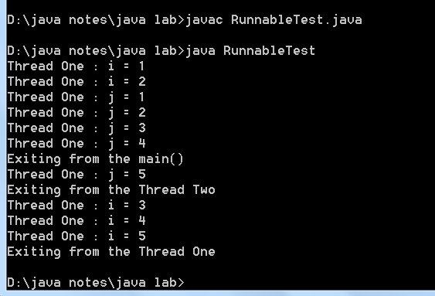

Inter-thread communication
Inter-Thread Communication can be defined as the exchange of messages between two or more
threads. The transfer of messages takes place before or after the change of state of a thread.
Inter-Thread Communication can be implemented with the following methods:
wait() : Sends the calling thread into the sleep mode.
This thread now can be activated only by notify() or notifyall().

final void wait()

notify() : Resumes the first thread that went into the sleep mode. The object class declaration of notify() method is shown below:

final void notify()
notifyAll(): Resumes (wakes up) all the threads that called wait(). The highest priority thread will run first.
final void notifyall()
All the methods are declared in the root class i.e., Object. Since the methods are declared as final they cannot be overridden.

